ICED ICF Attribution Tool

Overview
The ICED facility developed the ICF Attribution Tool to achieve the following objectives:
- To provide a simple and robust method for the ICED facility determine the proportion of its work which is eligible for climate finance from the International Climate Fund (ICF).
- To identify very simple entry points for all work packages to integrate (and prioritise) climate and environment opportunities
- To raise the level of ambition for ICED work packages to deliver better economic growth outcomes through climate and environment

The tool was developed in late 2016 and is currently in beta version. The tool is built on existing DFID guidance on ICF attribution and climate integration. The methodology is based on the OECD Development Assistance Committee 'Rio Markers', which is a sector-based system of attributing and tracking development finance flows for initiatives targeting climate change mitigation and adaptation. The basis of the Rio Markers is to identify the degree to which an activity’s objective to target climate change is either principle, significant, or not relevant (see Figure 1); this provides an indication of the degree of mainstreaming environmental considerations into programmes.

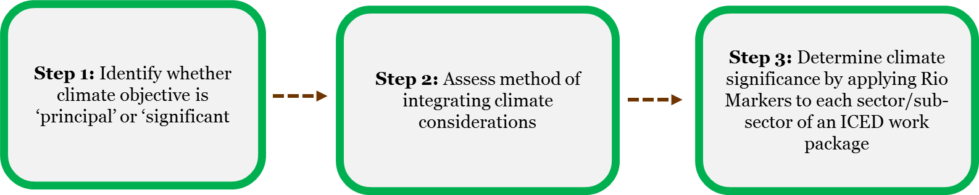
Figure 1: Overview of ICED ICF Attribution Tool method

Wider applicability
The draft ICED ICF Attribution Tool potentially has wider applicability across DFID, which may include:
- Supporting the Climate and Environment Department further develop this tool to inform future DFID ICF programme guidance
- Supporting ICF supported DFID programmes to review current ICF attribution in programming
- Supporting non-ICF supported DFID programmes to identify areas of C&E integration to access ICF funding

